Pure Peer-to-Peer (Pure P2P) System
# Source: AI Source: Provided by: [Data Path: Persons Table -> ID Column: 1, Name_En Column: Motasem Essam] -> From: [ChatGPT] on [1/16/2026]
A Pure P2P system is a type of Peer-to-Peer distributed system in which all nodes (peers) are completely equal and there is no central server at all—not even for coordination or lookup.

Definition
# Source: AI Source: Provided by: [Data Path: Persons Table -> ID Column: 1, Name_En Column: Motasem Essam] -> From: [ChatGPT] on [1/16/2026]
In a Pure P2P system:
- Every peer acts as both client and server
- No central authority exists
- Peers discover each other and share resources directly

Architecture Diagram
# Source: AI Source: Provided by: [Data Path: Persons Table -> ID Column: 1, Name_En Column: Motasem Essam] -> From: [ChatGPT] on [1/16/2026]
Peer A ---- Peer B
| \ |
| \ |
Peer C ---- Peer D
- No central node
- All peers have equal responsibilities

How Pure P2P Works
# Source: AI Source: Provided by: [Data Path: Persons Table -> ID Column: 1, Name_En Column: Motasem Essam] -> From: [ChatGPT] on [1/16/2026]
- A peer joins the network
- It discovers other peers through peer discovery protocols
- Requests and data are exchanged directly
- Peers leave and join freely

Key Characteristics
# Source: AI Source: Provided by: [Data Path: Persons Table -> ID Column: 1, Name_En Column: Motasem Essam] -> From: [ChatGPT] on [1/16/2026]
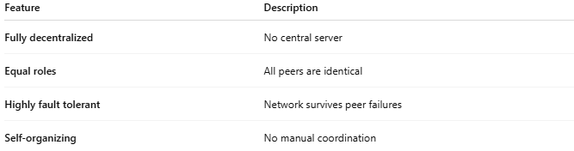
Feature | Description
Fully decentralized | No central server
Equal roles | All peers are identical
Highly fault tolerant | Network survives peer failures
Self-organizing | No manual coordination

Examples
# Source: AI Source: Provided by: [Data Path: Persons Table -> ID Column: 1, Name_En Column: Motasem Essam] -> From: [ChatGPT] on [1/16/2026]
- Early Gnutella
- Freenet
- Some blockchain networks (network layer)

Advantages
# Source: AI Source: Provided by: [Data Path: Persons Table -> ID Column: 1, Name_En Column: Motasem Essam] -> From: [ChatGPT] on [1/16/2026]
- No single point of failure
- Very high scalability
- Resistant to censorship and attacks

Disadvantages
# Source: AI Source: Provided by: [Data Path: Persons Table -> ID Column: 1, Name_En Column: Motasem Essam] -> From: [ChatGPT] on [1/16/2026]
- Difficult peer discovery
- High network traffic
- Hard to enforce security and trust
- Slower search performance

Pure P2P vs Hybrid P2P
# Source: AI Source: Provided by: [Data Path: Persons Table -> ID Column: 1, Name_En Column: Motasem Essam] -> From: [ChatGPT] on [1/16/2026]
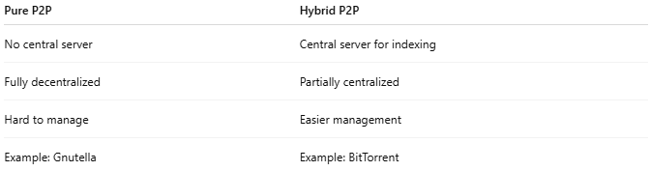
Pure P2P | Hybrid P2P
No central server | Central server for indexing
Fully decentralized | Partially centralized
Hard to manage | Easier management
Example: Gnutella | Example: BitTorrent

Simple Analogy
# Source: AI Source: Provided by: [Data Path: Persons Table -> ID Column: 1, Name_En Column: Motasem Essam] -> From: [ChatGPT] on [1/16/2026]
- Pure P2P: A group of people sharing files directly with everyone they know
- Hybrid P2P: A phone directory helps find people, but calls are direct

